
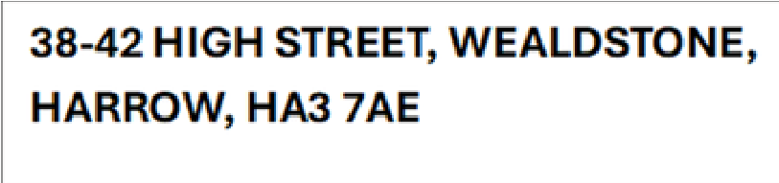
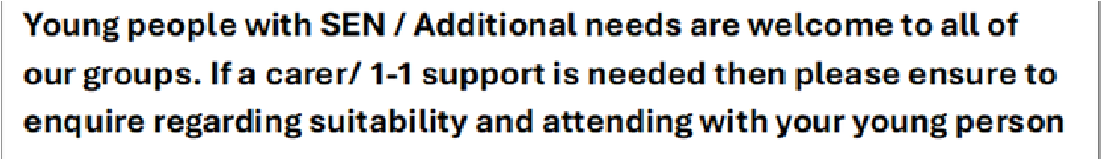

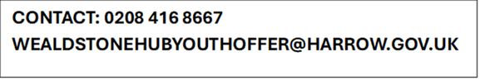


Activities start FROM 02 SEPTEMBER 2026
JUNIOR YOUTH
CLUB AT
WEALDSTONE
YOUTH CENTRE

Time:
3:30-5:30pm

Ages:
9-15

DROP IN OR BOOK
TO SECURE SPACE -
LIMITED AVAILABILITY

LEARN TO COOK AT
WEALDSTONE YOUTH
CENTRE

Time:
pm
3:30-5:30

All Ages
(may split
depending on age)

DROP IN OR BOOK TO
SECURE SPACE -
LIMITED AVAILABILITY
SENIOR YOUTH CLUB
AT WEALDSTONE
YOUTH CENTRE

Time:
5:00-7:00pm

Ages:
16-19/25 SEN

LIMITED SPACES PLEASE
BOOK
’S YOUTH CLUB
13-15
Time:
3:30-5:30pm
Ages
: 13-15

DROP IN OR BOOK TO
SECURE SPACE -
LIMITED AVAILABILITY
NO

SESSIONS
JUNIOR YOUTH
CLUB AT
WEALDSTONE
YOUTH CENTRE

Time:
3:30-5:30pm

Ages:
9-15

DROP IN OR BOOK
TO SECURE SPACE -
LIMITED AVAILABILITY

HARROW YOUTH
PARLIAMENT AT
WEALDSTONE YOUTH
CENTRE

Time:
pm
5:00-7:00
Ages
: 9-19
1 X A MONTH
Please call for more information

PLEASE CALL TO FIND
OUT MORE DETAILS

HARROW EARLY HELP YOUTH OFFER - TERM TIME
MONDAY
TUESDAY
THURSDAY
WEDNESDAY
FRIDAY
T
I
M
E
T
A
B
L
E
!

