
BTEC Applied Science
National Extended Certificate
Awarding Body:  Pearson/Edexcel  Who is the course for?  Designed for learners who are interested in learning about the sector alongside other fields of study, with a view to progressing to a wide range of higher education courses, not necessarily in applied science. To be taken as part of a programme of study that includes other appropriate BTEC National or A levels.  What can it lead to?  National Extended Certificate 360 GLH is equivalent to 1 A level  After the completion of the course, learners can follow the university route or higher national route  What are the entry requirements?  At least 5 Grade 4s or above at GCSE including Mathematics and/or English Language and at least a grade 44 in Combined Science.  What will I Study?  National Extended Certificate is equivalent to 1 A level consists of 4 units altogether. It consists of 3 mandatory units and one optional. Of these 2 are assessed externally and the other two are internally assessed.  Which skills will I acquire?  Cognitive, composing and problem-solving skills, as well as interpersonal skills.  How will I be assessed?  Two units consist of an external written exam set and marked by Pearson/Edexcel. Assignments for both mandatory and optional units are internally marked and externally verified by Pearson. Assignments will be graded as Pass, Merit or Distinction. | Assessment 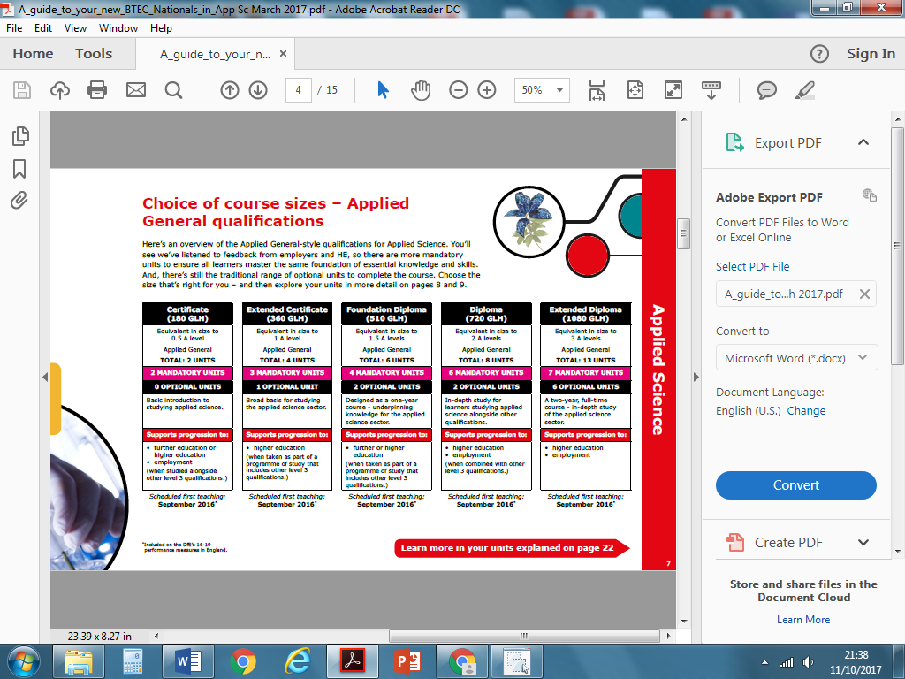  What equipment or materials will I need?  It will be necessary to purchase a lab coat and a textbook (approximately £30 per book)  Course Offer Conditions  Rooks Heath expects to run courses that are offered. However, courses that do not recruit to a satisfactory level may be offered at another Centre or withdrawn.

